Functional Specifications

- Add an additional column SELECT in the ALV output in the form of checkbox. 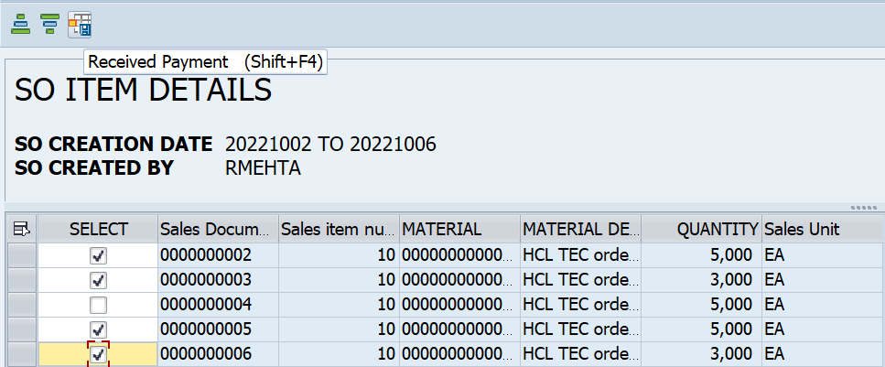

- Only the selected rows need to be displayed in the smartforms and Adobe forms.

- If user does not select any rows, then all rows need to be displayed in the smartforms and Adobe forms.

